Linux File Hierarchy Structure

The Linux File Hierarchy Structure or the Filesystem Hierarchy Standard (FHS) defines the directory structure and directory contents in Unix-like operating systems.
It is maintained by the Linux Foundation.

- In the FHS, all files and directories appear under the root directory /, even if they are stored on different physical or virtual devices.
- Some of these directories only exist on a particular system if certain subsystems, such as the X Window System, are installed.
- Most of these directories exist in all UNIX operating systems and are generally used in much the same way; however, the descriptions here are those used specifically for the FHS and are not considered authoritative for platforms other than Linux.
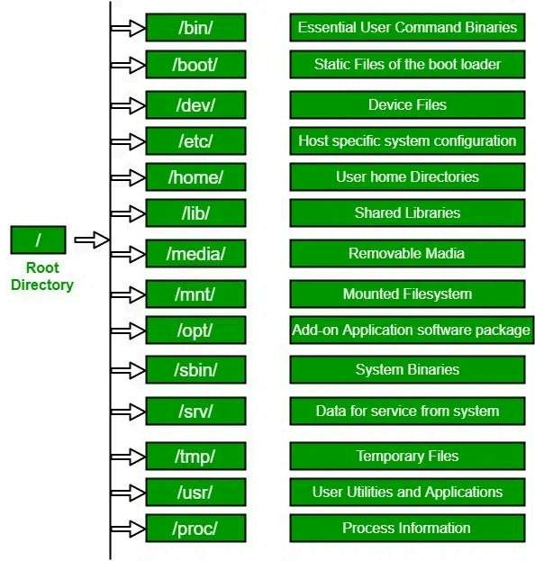

1. / (Root):
At the top of every Linux file system is the root directory represented by a forward slash /.
It’s the base point, and no directory exists above it.
All other directories branch out from this root directory.
- Every single file and directory start from the root directory.
- Only root user has the right to write under this directory.
- /root is the root user’s home directory, which is not the same as /

Only the root user has permission to modify contents inside this directory. Regular users cannot make changes here.
For example, if you attempt to create a file in / as a non-root user, you’ll encounter a "Permission Denied" error.

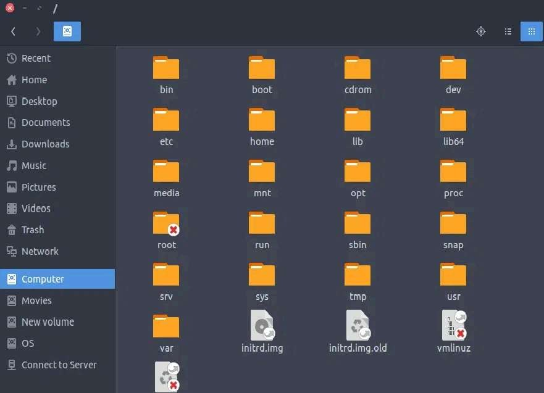

2. /bin :
The /bin directory contains essential commands and binaries needed by all users, including cp, ls, ssh, and kill. These commands are universally available across user types.
- Contains binary executables.
- Common linux commands you need to use in single-user modes are located under this directory.
- Commands used by all the users of the system are located here e.g. ps, ls, ping, grep, cp

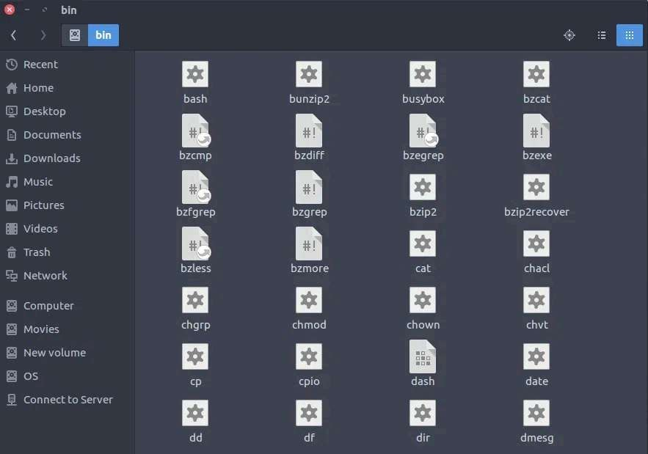

3. /boot :
This directory stores all files required for booting the system.
It includes the GRUB bootloader configuration and essential kernel files that are loaded during startup.
- Kernel initrd, vmlinux, grub files are located under /boot
- Example: initrd.img-2.6.32-24-generic, vmlinuz-2.6.32-24-generic

Note: GRUB is the default bootloader for most Linux distributions.
It presents a menu at startup where users can choose which OS/kernel to boot (useful in dual-boot systems), and it passes control to the selected OS.
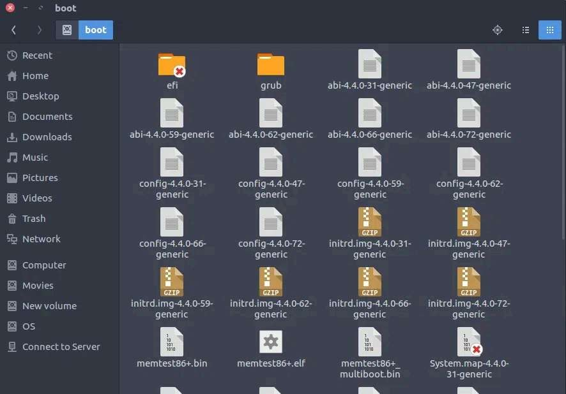

4. /dev :
Device files in Linux are stored in the /dev directory.
These are special files that act as interfaces between hardware and software. Device files are of two types: block devices (e.g., hard drives) and character devices (e.g., microphones and speakers).
Examples include /dev/sda1 for disk partitions.
- These include terminal devices, usb, or any device attached to the system.
- Example: /dev/tty1, /dev/usbmon0

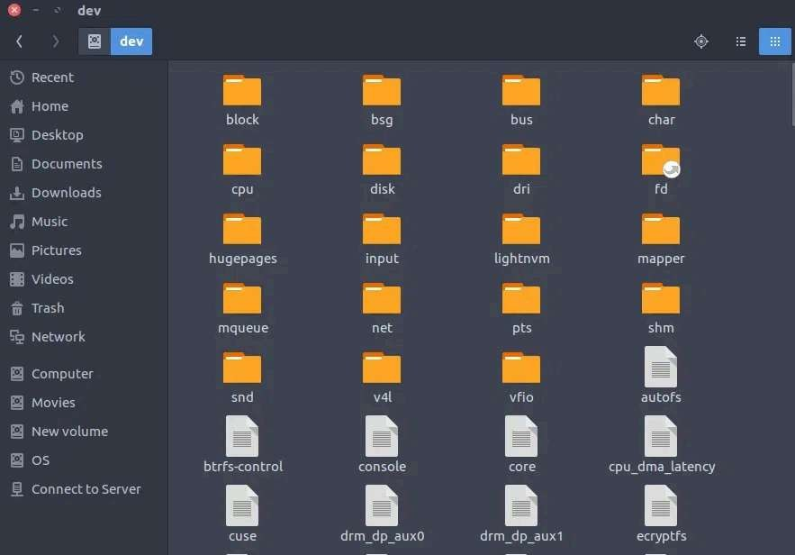

5. /etc :
Short for "Editable Text Configuration," /etc contains configuration files for system applications, users, services, and tools or it contains the Host-specific system-wide configuration files.
For example, user details like UID and local addresses are defined here.
- This also contains startup and shutdown shell scripts used to start/stop individual programs.
- Example: /etc/resolv.conf, /etc/logrotate.conf.
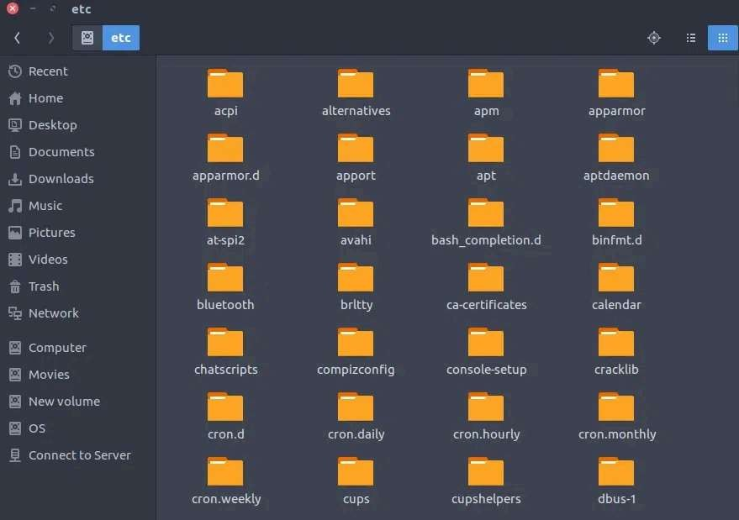

6. /home :

Every non-root user has a personal directory inside /home.
For example, if your username is johndoe, your personal directory would be /home/johndoe.
Each user can create, delete, or modify files only in their own home directory and cannot access others’ home directories.
- Home directories for all users to store their personal files, containing saved files, personal settings, etc..
- example: /home/bca, /home/kv
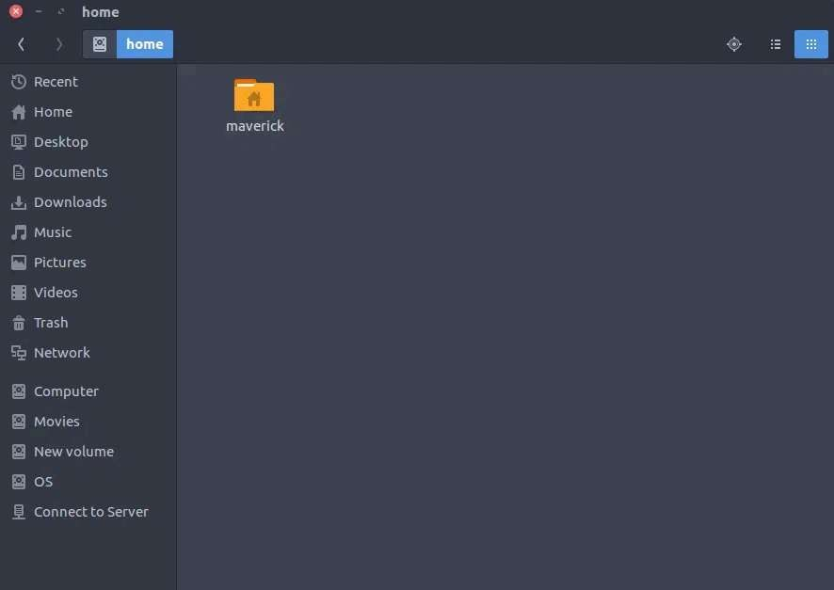

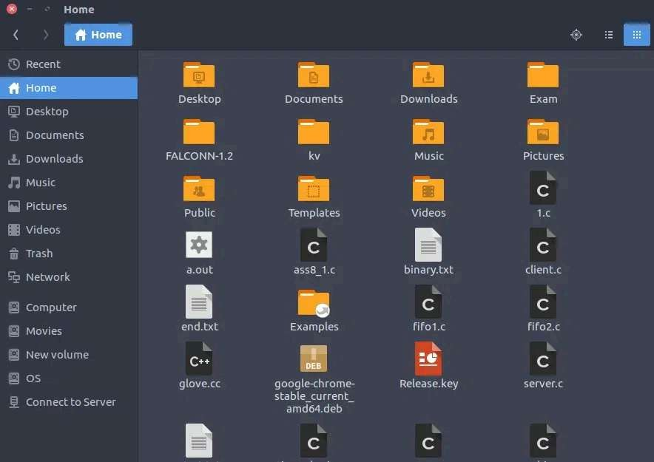

7. /lib:
Applications require shared libraries to run, which are stored in /lib.
These include dynamic libraries needed during runtime.
For example, Apache server libraries are available here.
- Library filenames are either ld* or lib*.so.*
- Example: ld-2.11.1.so, libncurses.so.5.7
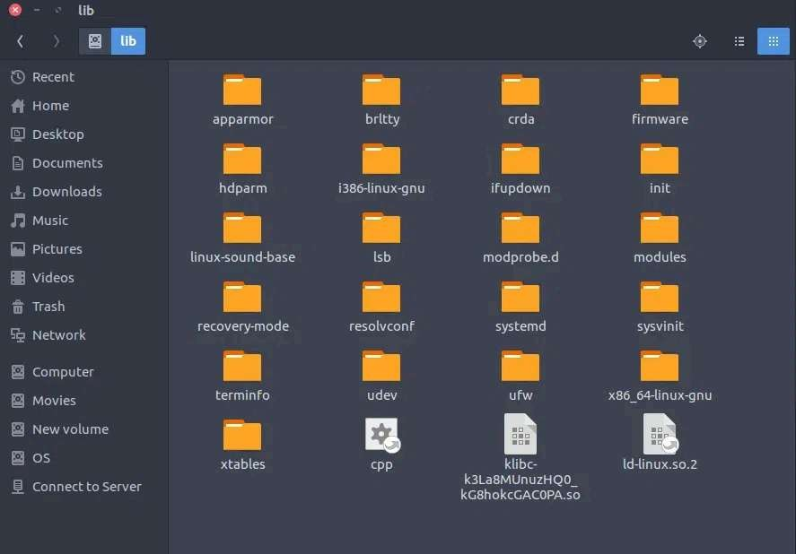

8. /media:
Devices like USBs, CDs, and pen drives are mounted under /media.
For example, when a CD-ROM is inserted (appeared in FHS-2.3), its details will appear here.
- Temporary mount directory for removable devices.
- Examples, /media/cdrom for CD-ROM; /media/floppy for floppy drives; /media/cdrecorder for CD writer
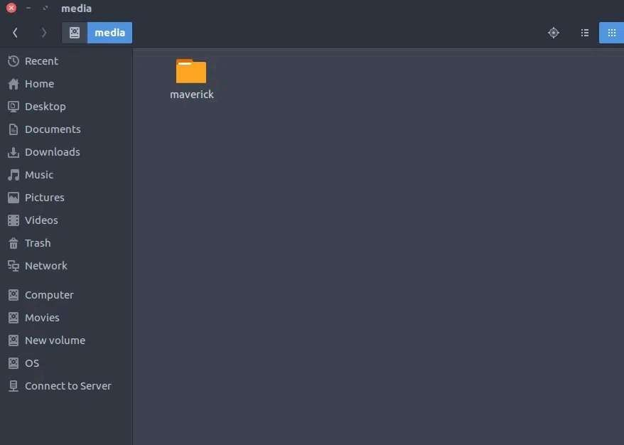

9. /mnt :
When external drives are connected, they are temporarily mounted in /mnt. This is where their contents become accessible to the system.
- Temporary mount directory where sysadmins can mount filesystems.
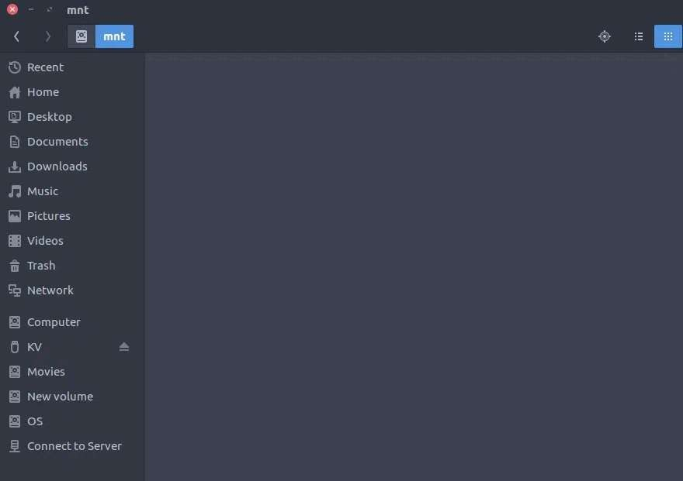

10. /opt :
Third-party software and packages not part of the default system installation are stored in /opt. It includes their configuration and data files.
- Contains add-on applications from individual vendors.
- Add-on applications should be installed under either /opt/ or /opt/ sub-directory.
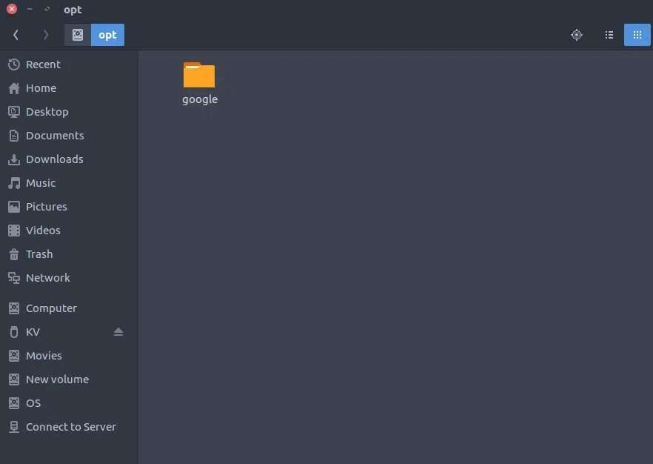

11. /sbin :

- Essential system binaries.
- This directory holds administrative binaries like iptables, firewall management tools, fsck, init, route etc.
- These binaries are primarily for system administrators and typically require root privileges to execute.
- Just like /bin, /sbin also contains binary executables.
- The linux commands located under this directory are used typically by system administrators, for system maintenance purposes.
- Example: iptables, reboot, fdisk, ifconfig, swapon

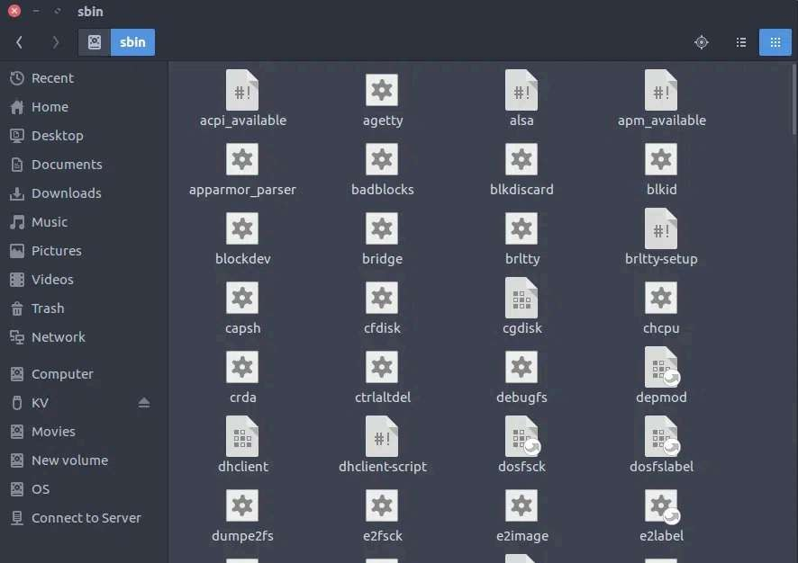

12. /srv :
Site-specific data served by system, such as data and scripts for web servers, data offered by FTP servers, and repositories for version control systems.
- srv stands for service.
- Contains server specific services related data.
- Example, /srv/cvs contains CVS related data.
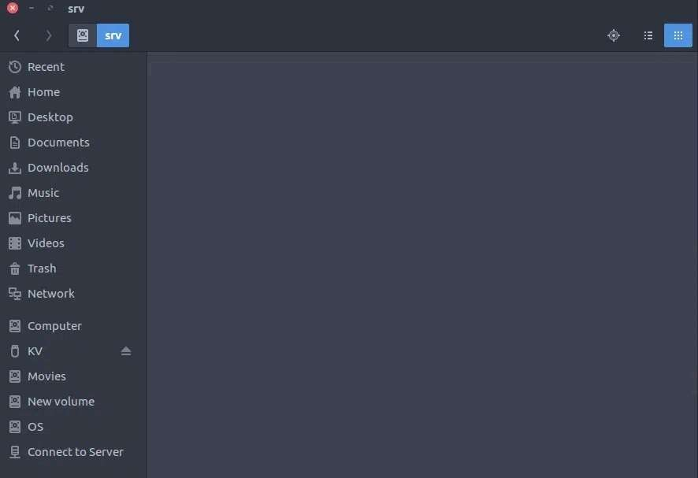

13. /tmp :
Programs create temporary files during execution, and these are stored in /tmp. These files are deleted automatically after the program finishes or when the system is restarted.
- Directory that contains temporary files created by system and users.
- Files under this directory are deleted when the system is rebooted.
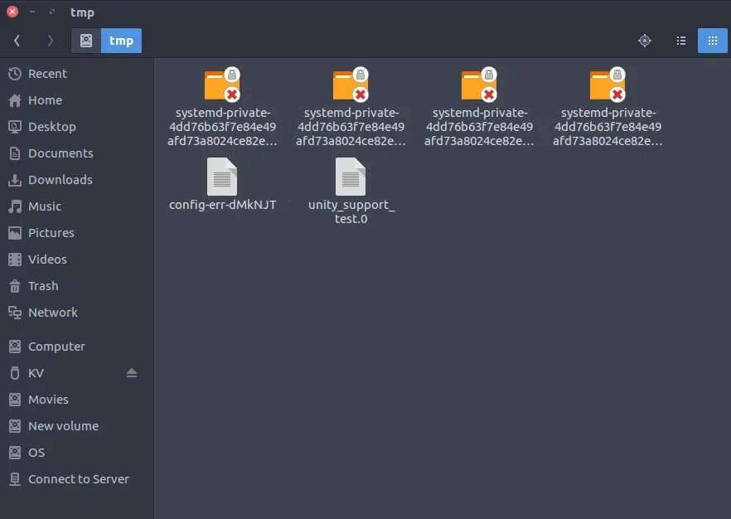

14. /usr :
Secondary hierarchy for read-only user data;
Contains the majority of (multi-)user utilities and applications.
- Contains binaries, libraries, documentation, and source-code for second level programs.
- /usr/bin contains binary files for user programs. If you can’t find a user binary under /bin, look under /usr/bin. For example: at, awk, cc, less, scp
- /usr/sbin contains binary files for system administrators. If you can’t find a system binary under /sbin, look under /usr/sbin. For example: atd, cron, sshd, useradd, userdel
- /usr/lib contains libraries for /usr/bin and /usr/sbin
- /usr/local contains user's programs that you install from source. For example, when you install apache from source, it goes under /usr/local/apache2
- /usr/src holds the Linux kernel sources, header-files and documentation.

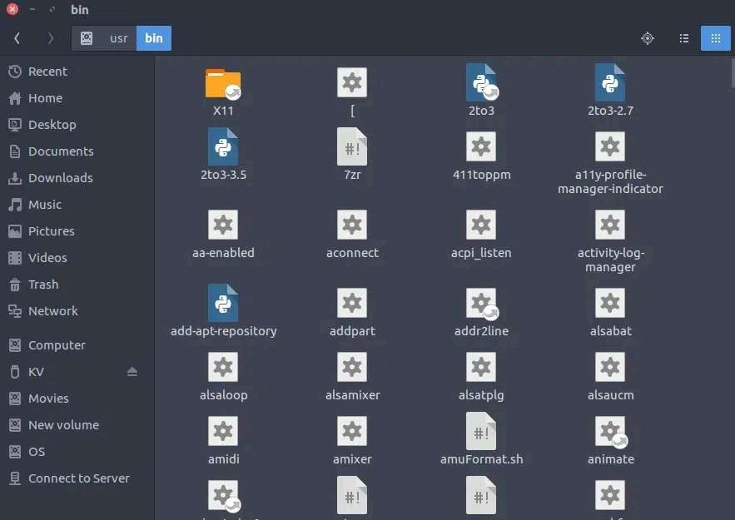
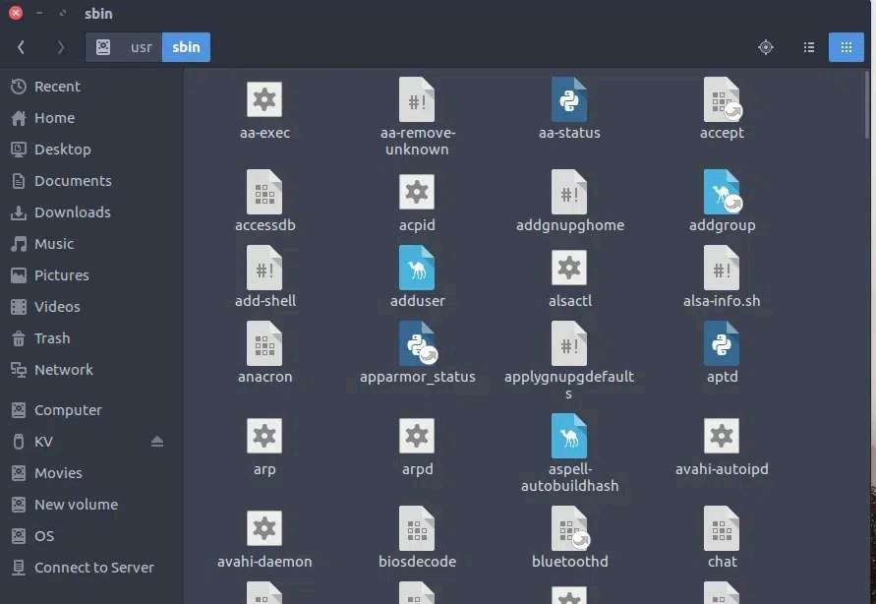
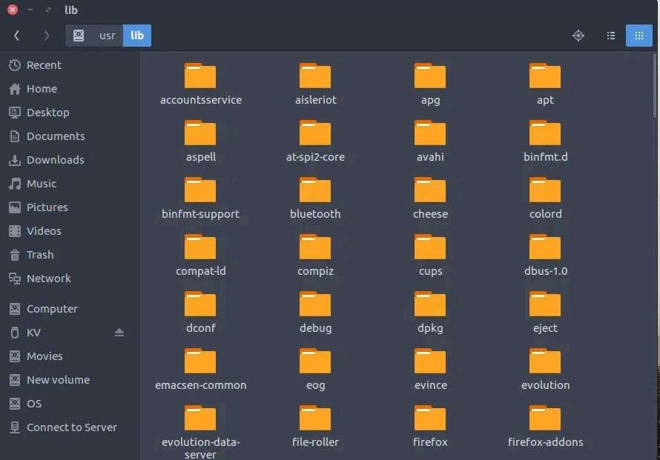

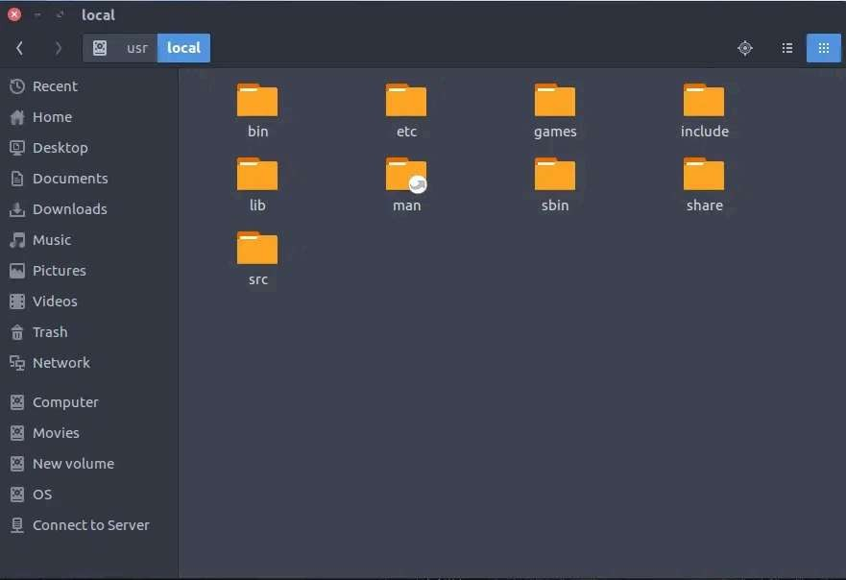

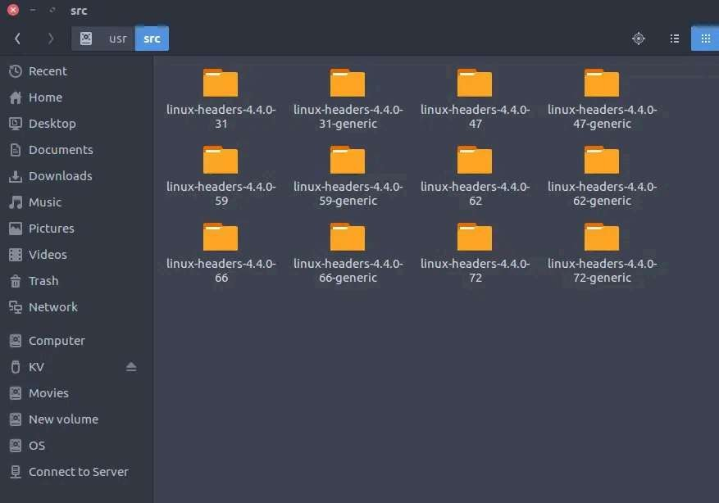

15. /proc:
The /proc directory provides detailed information about system processes. Each process is assigned a unique ID and represented as a directory inside /proc.
For example, /proc/meminfo gives real-time data about memory usage including total, free, buffer, and cache statistics.
- Contains information about system process.
- This is a pseudo filesystem that contains information about running processes. For example: /proc/{pid} directory contains information about the process with that particular pid.
- This is a virtual filesystem with text information about system resources. For example: /proc/uptime
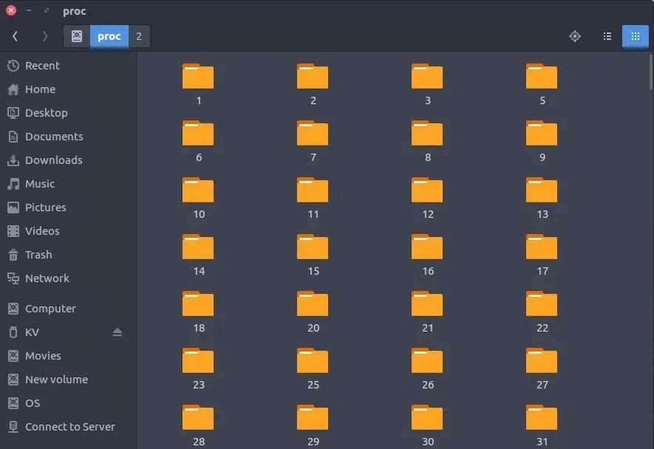
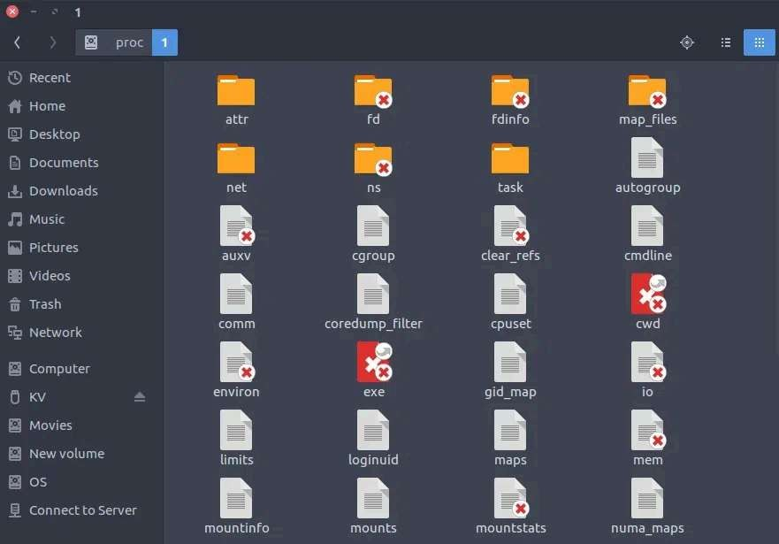

The Linux File System (FHS) to store everything like programs and settings to your personal files. It starts at the root folder (/) and organizes files into special folders with specific jobs. Key folders include /home for your personal files, /etc for system settings, /bin for essential commands, and /tmp for temporary files. This organization keeps Linux systems tidy, secure, and consistent across different computers.

